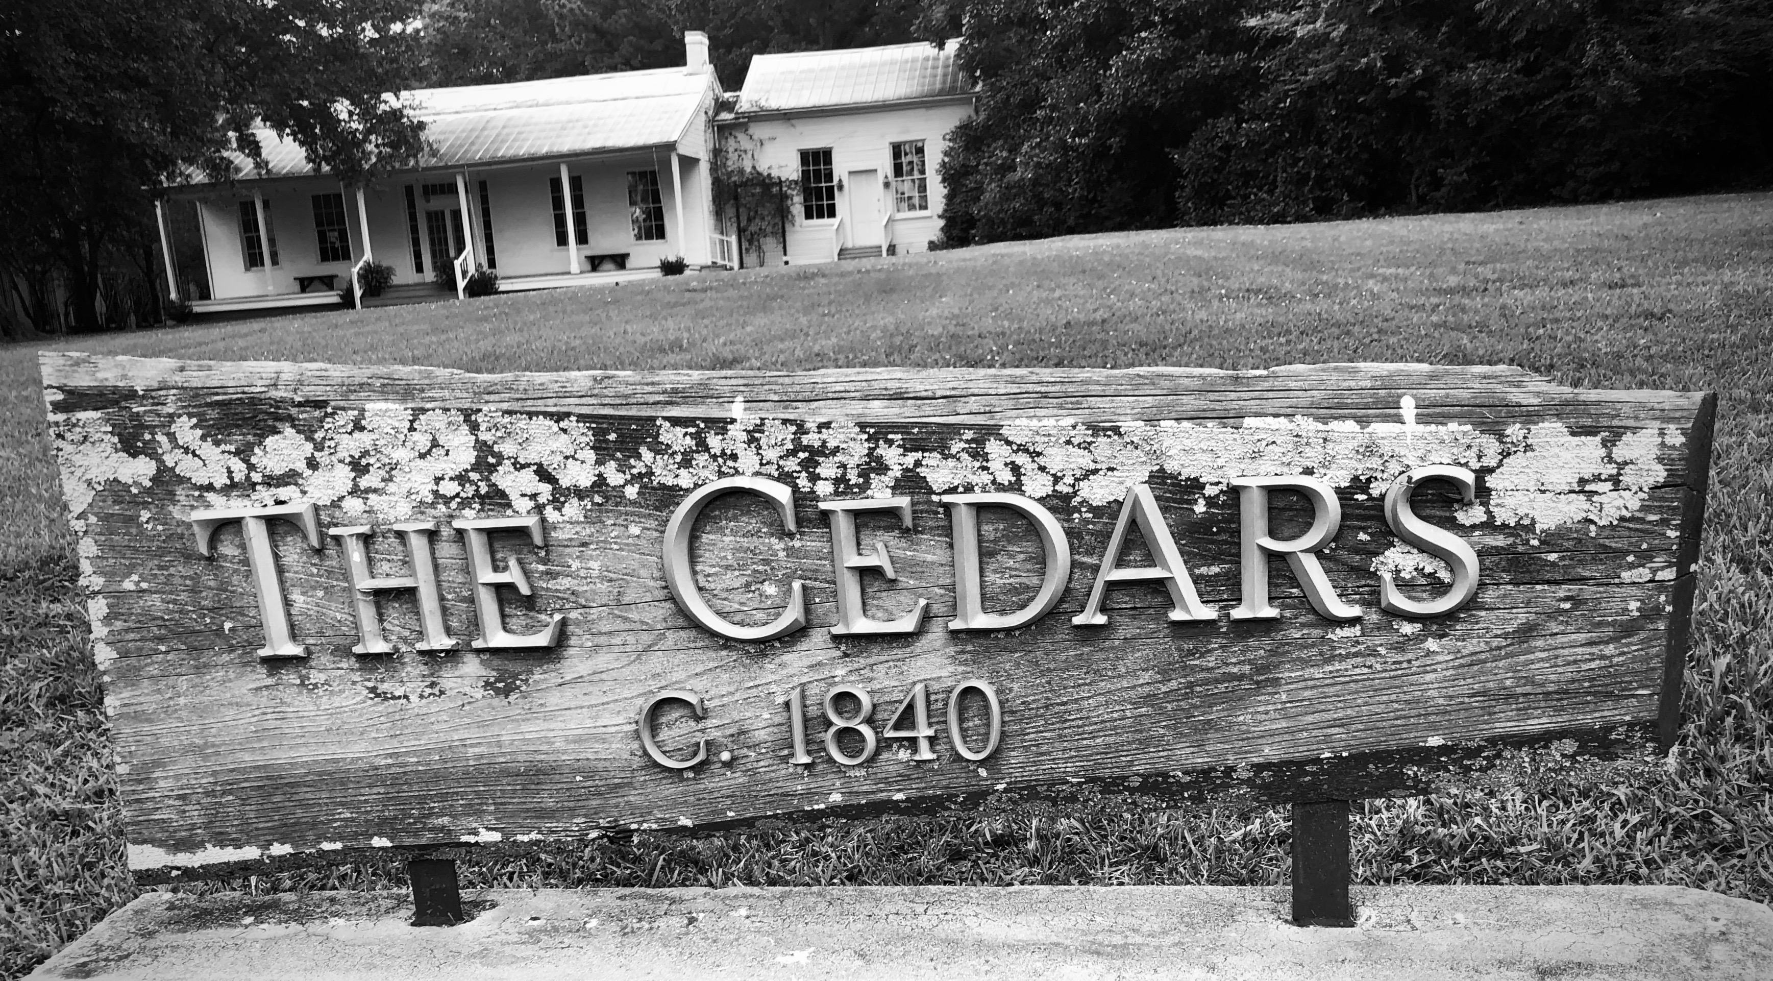
R E N T A L A G R E E M E N T

This is a contract between Fondren Renaissance Foundation, owner of The Cedars, and:

Renter Name___________________________________________________________

Renter Mailing Address_________________________________________________

___________________________________________________________

Phone_________________________________________________________________

Email address__________________________________________________________

For the following event

Type of Event _________________________________________________________

Name of Event________________________________________________________

Date of Event_________________________________________________________

For a Total Fee of (see work sheet)___________________________________________

Renter agrees to the terms and conditions accompanying this contract.

Renter agrees to indemnify and hold harmless the Fondren Renaissance Foundation, its employees, directors, officers and agents from any and all claims, demands, losses, damages, expenses and liabilities. This includes reasonable attorney’s fees and expenses incurred by Fondren Renaissance Foundation in enforcing this provision.

Signature (Renter)___________________________________________________________

Signature (FRF)______________________________________________________________

Date:_____________________________________________________________________
Terms and Conditions for Cedars Rental Agreement

- Renter agrees to a non-refundable booking fee of $200 to reserve facility

- Renter agrees to pay $500 installment 60 days in advance of event

- Renter agrees to submit Fee Worksheet and pay balance (-$200 booking fee) 30 days in advance of event

- Renter shall be responsible for and agrees to indemnify, defend and hold harmless the Fondren Renaissance Foundation, its employees, directors, officers and agents from any and all claims, demands, losses, damages, costs, expenses (including reasonable attorney’s fees) and liabilities (collectively, “Liabilities”) incurred as a result of, relating to or arising from the Event, including, but not limited to, any and all Liabilities arising from the consumption of alcoholic beverages or illegal narcotics on the premises of the Cedars. Renter agrees to immediately notify Fondren Renaissance Foundation of any Liabilities related to the Event by calling Rebecca Garrison at (916)-812-5678..

- Renter agrees to purchase Event Insurance which includes general liability coverage and, if applicable, liquor liability coverage, no later than 10 days prior to the event, at the renter’s expense. The policy shall include but not be limited to bodily injury and property damage liability. The insurance shall have a single limit liability of not less than $1 million and general aggregate liability of not less than $2 million. Fondren Renaissance Foundation shall be named as an additional insured.

- Renter agrees that any and all liabilities arising from the consumption of alcoholic beverages or illegal narcotics on the premises are the responsibility of the renter.

- Friday/Saturday events must end at or before 11 p.m. Otherwise, events must end at 10 p.m.

- Amplified music must end at 9 p.m., regardless of day of the week. Music agreement required.

- Renter bears sole responsibility for decorating The Cedars for the event. This includes, but is not limited to, providing linens, dinnerware, glassware, flatware, floral arrangements, tables, chairs, etc.

- Renter may use existing string/bistro lighting in the back yard at no extra expense. If renter desires a tent or other structure to be located in the back yard, a $500 fee will be charged to remove and replace existing lighting.

- Renter agrees to use and occupy the premises in accordance with all applicable local, state and federal laws and ordinances.

- Smoking is not permitted on the premises, including the building or grounds. No open flames are permitted indoors or on the porches. Votive candles may be used when confined to non-flammable containers. Sparklers and fireworks are not allowed on the premises.

- No nails, tacks, staples or tape shall be used to attach anything to the walls, flooring, trim or ceiling without prior approval.

- No glitter or rice shall be used; birdseed may be used on the grounds but not in the house or porches, Confetti is not allowed.

Renters Initials___________________ Date__________________

- Up to 10 cars may park on the paved portion of the premises. Parking on the grass is strictly prohibited and applies to caterers, set-up and tear-down crews and guests. No vehicle is allowed on the front lawn at any time.

- Additional parking can be arranged through Quinta Clark (601-421-4921) of Hinds County Sheriff’s Department. Valet parking is also available through Ms. Clark.

- Renter shall be responsible for obtaining all personnel necessary to conduct the event safely and in accordance with the rental agreement, including but not limited to security guards, caterers, decorators, etc.

- Renter agrees to restore the premises, including equipment, furniture, furnishings, etc., to the same condition found before the event (see Cleaning Check List) Up to $600 fee for not restoring..

- Renter understands that a final inspection will take place after the event with any issues documented with photos and presented for restitution.

Notes: ___________________________________________________________________________

_________________________________________________________________________________

_________________________________________________________________________________

_________________________________________________________________________________

_________________________________________________________________________________

_________________________________________________________________________________

_________________________________________________________________________________

Renters Initials___________________ Date__________________

The Cedars Fee Worksheet

Rental Fees Schedule

Friday 10 a.m. – Sunday 5 p.m. $3,500 ____________________

Two day rental* $2,500 ____________________

One day rental (7 a.m. – 11 p.m.)* $1,500 ____________________

Additional hours @ $200 an hour ______ ____________________

Other ____________________

*must include decorating and clean up

Add-Ons

Grass Fees* $250 ____________________

Welcome Banner $200 ____________________

Unlimited use of graphic $25 ____________________

Cleaning Fees $300 ____________________

Removing bistro lights in back yard $500 ____________________

Total FEES $_____________________

Date Paid

____________ ___________ $200 non-refundable booking fee

_________ ___________ $500 installment (Due ______________________________)

_________ ___________ Balance of $_____________ (Due __________________)

Notes:_____________________________________________________________________________

___________________________________________________________________________________

___________________________________________________________________________________

___________________________________________________________________________________

*Grass fees apply when if the lawn is used for anything other than normal walking or event set-up i.e. dance floor, platform, staging, etc. Does not apply to tent, table and chair set up.

Parking at The Cedars

Contact for Parking Management

Steve Lofton
Hinds County Sheriff’s Department
601-331-7748

For event that require parking for more than 20 cars, off-site parking arrangements should be made by contacting Steve Lofton.

There are two parking options:

- Secure parking across the street at St. Andrew’s Lower School. Guards will monitor parking lot and insure safe pedestrian crossing of Old Canton Road.

- Valet Parking. Guests will drive to the valet stand on the grounds for a licensed, bonded parking attendant to park cars on site and at St. Andrews.

Both options are arranged through Mr. Lofton. Costs vary depending on number of guests and length of the event. Generally, one parking attendant will range between $25 and $35 per hours with a minimum of 4 hours charged.

Other considerations:

- St. Andrew’s Parking will generally not be available for weekday events while school is in session.

- If the event is a weekday event beginning before 6 p.m., during the school year, two parking guards will be required.

- Parking lot gates at St. Andrews will be locked at 10:30 p.m. Sunday through Thursday, and 11:30 p.m. Friday and Saturday.

- If St. Andrew’s parking is utilized, renter shall indemnify and hold The Cedars, FRF, Steve Lofton and parking attendants harmless.

Event Insurance
Can be purchased through any vendor (see vendor list), or from Ross & Yerger by contacting Tamisha Broadwell: tbroadwell@rossandyerger.com or tel:601.360.8790

MUSIC AGREEMENT

The Cedars operates under a special use permit granted by the City of Jackson. The permit is intended to provide protections to our neighbors who live next to The Cedars.

To insure that their peace is not disturbed during an event at The Cedars, the following rules must be obeyed:

- Any amplified music must end by 9 p.m.

- No music with heavy bass sounds can be played after 7 p.m.

- Amplified music must be kept to volumes that do not disturb neighbors

- If any neighbor requests that music volume be lowered, renter must comply.

Renter acknowledges the above and understands that penalties for non-compliance will be applied.

Renter_______________________________________________________

DJ/Band leader_______________________________________________

Date________________________________________________________

This agreement is due 10 days prior to the event

